HTML Fundamentals

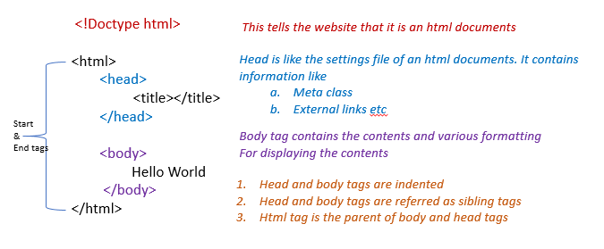

1. **Header** Tags – h1 through h6 - <h1>My Website</h1>
2. **Paragraph** There could be any number of paragraphs
3. **Subscript** - <p>H<sub>2</sub>O</p>
4. **Superscript** - <p>10<sup>2</sup></p>
5. Make certain value or word **small** – <small>This</small>
6. Make certain value or word **big** – <big>This</big>
7. Make certain value or word **bold** - <b>paragraph1</b>
8. **Italicize** a word or value - <i>paragraph1</i>
9. Add **space between** paragraphs <br/><br/>
10. **Horizontal rule** tag (draws a line from left to the right of page) <hr/><hr/>
11. Provide a **link** **to external website**, *other .html pages, images etc.*

* **<a href** = "https://www.google.com"**><h1>**Google Homepage**</h1></a>**

1. **Insert** **image**; src – could be a link or an image saved in the same or different folder; the resolution can be specified (or width & height be specified.). Alt is a backup or description of the image; in case the image is accidentally deleted etc…

* <img **width ="100"** src ="python.png" alt ="This is pythons Logo "/>

1. **Add** **image** (poster- the first look/image; autoplay – so the video starts to play automatically)

* <video src = “tutorial.mp4 controls autoplay poster=”thumb.jpg” width =”300”</video>

1. **Table** **Tags**

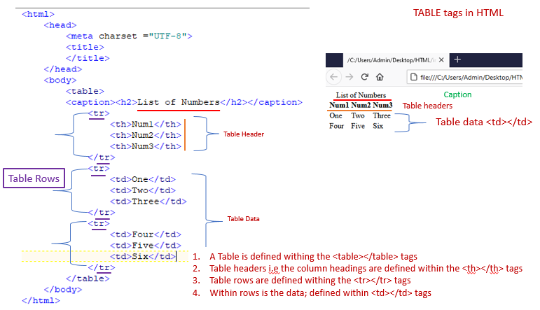

1. **Lists**

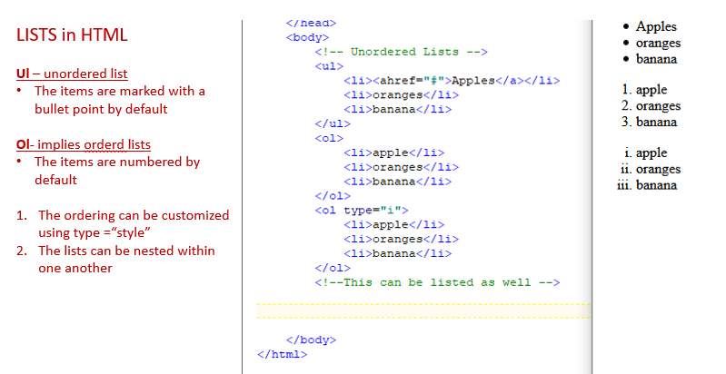

1. **Div & Spans** can be considered as container or wrapper tags in HTML.

Div and Spans allow us to segment portions of the HTML, this way, we can apply color and style to just that specific segment of the HTML

* 1. Div is a container for block elements
     1. Block elements take entire space width wise and cannot be placed next to one another.
  2. Span is a container for inline Elements
     1. Inline elements take as much space as required and can be placed next to one another

1. **Input and Forms**- Input (radio button/checkbox/text box) are used to accept input from a user.

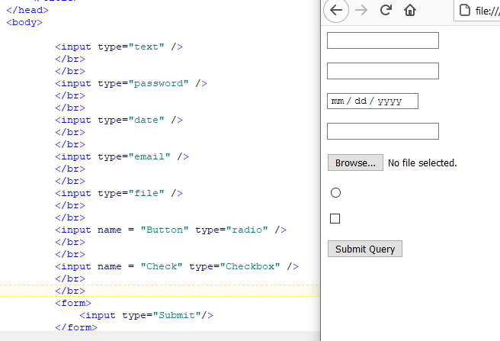

* 1. **Examples of Forms**

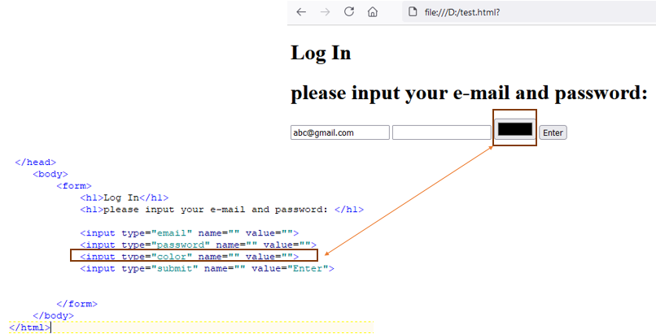

* 1. **Add label to elements of a Form**

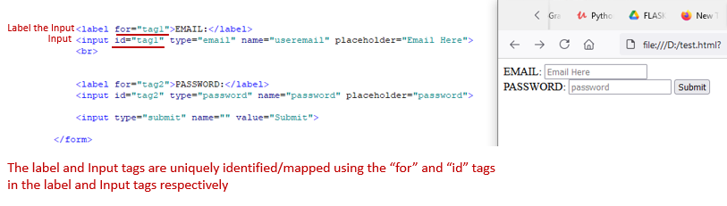

* 1. **Add radio buttons and link them**

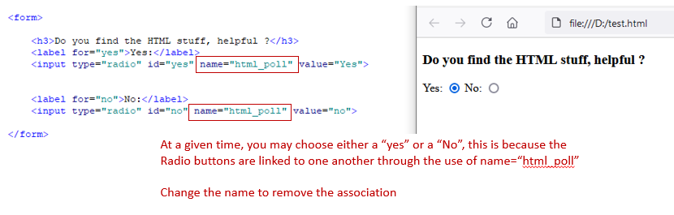

1. **Pass values through GET method**

While on the front-end things appear fancy, at the backend data is moved around in the form of key value/name value pairs.

* 1. **A drop-down menu**

